**Ionospheric Scintillation Morphological Analysis Using GPS-SCINDA Data at Low Latitude Ground Station**

Mohammed Ayalew and Tsegaye Kassa

**Abstract**

*This study aims to present the morphology of GPS L-band scintillations at the equatorial anomaly station Bahir Dar (11030’N, 37030’E) using GPS-SCINDA data in the descending high solar activity period between January 2014 to December 2014. In studying low-latitude scintillation, we have used millions of data recorded every minute of one year by 32 GPS satellite and it is found that intense scintillation occurred during the day time with a small frequency and very frequent occurrences of relatively moderate scintillation during the night time. In the period of observation, the variation of scintillations with local time and season are analyzed and it is found that occurrence of scintillation is minimum in summer months and maximum in equinox months with highest values observed in the months of March and September. Pre-midnight and post-midnight occurrence of scintillation is also studied and Pre-midnight scintillation was found to be maximum in equinox whereas it is minimum in winter months. Generally, it is found that most of scintillations are weak (s4<0.1) and intense scintillations with s4>0.3 are rare.*

# Introduction

The ionosphere is a partially ionized part of the upper atmosphere where free electrons are concentrated and affect the propagation of GPS radio frequency electromagnetic waves. The ionosphere owes its existence to the sun through photoionization. The Sun continuously emits energy into space in the form of electromagnetic (EM) radiation and energetic particles in what is called solar wind. The solar wind, which expands out into the Solar System carrying with it the Sun’s magnetic field, carves out a region of interplanetary space called the heliosphere and forms the interplanetary magnetic field. The solar wind and EM radiation is not steady due to the dynamic processes in the sun. Among the most prominent indicators of its evolving, non-static nature of sun are sunspots. Sunspots appear as dark areas on the solar surface and have been observed to peak in number approximately every 11 years [1]. The natural differential rotation of the sun triggers sunspots to collide and causes violent eruption of radiation and matter, solar flare and coronal mass ejection (CME) respectively, in a period of approximately eleven years, known as the solar cycle shown in figure 1. The ejection of sudden CME causes a disturbance in the interplanetary magnetic field and initiates a disturbance on the geomagnetic field, known as the geomagnetic storm. Due to the interaction of geomagnetic field with the ionospheric plasma, geomagnetic storm triggers electron density irregularities. Thus, electron production and irregularities in the ionosphere is controlled by ionization processes that primarily depend on a wide spectrum of solar X-ray and extreme ultraviolet (EUV) radiation which varies with the Sun’s activity. Without the solar activity, the ionosphere would possess a reasonably deterministic variability, which is associated with the local solar zenith angle, including diurnal and seasonal effects that are appreciably controlled by geometry. Therefore, ionospheric electron density depends on time (diurnal and seasonal), geographical location (polar, auroral zones, mid latitudes, and equatorial regions), and with certain solar related ionospheric instabilities. These changes affect Earth’s space environment in a number of ways, including increased solar wind that bombards Earth’s upper atmosphere, causing aurorae and large electrical currents that can disrupt communication, power grids, and satellite navigation including the GPS system.



Figure 1: The butterfly diagram of sunspot groups.

One of the first known effects of space weather on GPS was fluctuations in the amplitude and phase of GPS radio signals known as ionospheric scintillation. Ionospheric scintillation is a rapid and irregular fluctuations of amplitude and phase of radio wave transmissions from satellites received at the earth surface resulting from electron density irregularities in the ionosphere [2]. The fluctuations in electron density cause perturbations in the index of refraction of the ionosphere, which in turn cause diffraction of the radio waves. Multiple diffracted wave fronts, with different phases, reach the antenna receiver at the same time. Because the ionospheric irregularities causing the diffraction as well as the GPS satellites are moving, the receiver experiences alternating periods of constructive or destructive signal interference, and fluctuations in the phase and amplitude of the received signal develop.

Although scintillation can occur anywhere over the Earth, globally there are two zones of severely affected by scintillation activity, one in the equatorial zone which extends up to ±20◦ in geomagnetic latitude around the magnetic equator forming a scintillation belt that encompasses approximately 1/3 of the Earth’s surface and another at high latitudes in the vicinity of auroral to polar latitude. In the equatorial zone, enhanced scintillation activity has been observed in the equatorial ionization anomaly (EIA) belt (10–20◦ lat. on either side of the magnetic equator) as compared to that at nearby low latitudes. This region is highly dynamical, unpredictable and is characterized by the existence of intense plasma irregularities which affect almost all radio communication systems utilizing the earth space propagation path. Ionospheric scintillations, the most significant manifestation of ionospheric irregularities, poses a challenge to GPS users, satellite communications, and radar system performance and radio astronomical observations [3]. Ionospheric scintillation will degrade the GPS signal quality, reduce its information content, or cause failure of the GPS signal reception and under the worst of conditions, it can lead to communication blackouts [4]. With the increasing applications of Global Positioning Systems (GPS) and satellite-based communication and navigational systems, especially when the millimeter range precision approach is required, the precise occurrence characteristics and prediction of the intensity of scintillations and their effects on L- band frequencies is important.

# Related Works

Extensive studies of GPS ionospheric scintillations have been carried out over the past four decades in different parts of the world under national and international space weather science research programs. A number of reviews articles covering different aspects and features of ionospheric scintillations and ionospheric irregularity mechanisms based on theoretical and experimental observations have been published. These studies indicated that scintillations phenomenon have strong diurnal, seasonal, geographic and solar cycle dependence being at their most severe during the evening hours, in the months of the equinox, at equatorial latitudes and during the years of solar maximum.

As the ionosphere over Ethiopia is situated in one of the highly dynamic regions of the world, covering the geomagnetic equator to the ionization anomaly crest region and beyond, a GPS scintillation network decision aid (GPS-SCINDA) station was established at Bahir Dar with help of US Air Force to study the temporal, seasonal, solar activity variations of scintillations. In this study, we have investigated GPS scintillations from data collected at the equatorial anomaly station Bahir Dar for the descending high solar activity period 2014-2015. During the observation period, scintillation parameters were extracted from dual frequency GPS receiver installed at Bahir Dar.

# Data and Methodology

## Experimental Setup

When the irregular electron content of the ionosphere drift across the path of the GPS signal, the spatial pattern of varying intensity is converted into temporal fluctuations or scintillations and recorded by GPS ionospheric scintillation and TEC monitoring (GISTM) ground receiver. The scintillation data used in this study originates from GISTM measurement using high data- rate Novatel GSV400B GPS SCINDA dual frequency (L1=1575.42 MHz and L2=1227.60 MHz) receiver situated at Bahir Dar University, Bahir Dar, Ethiopia (lat. 23.2º N, long.77.6º E) near the northern crest of the equatorial anomaly. The site located near the crest of the equatorial ionization anomaly and therefore well situated for the measurement of TEC and Ionospheric scintillation. This has been the drive for the commencement of ionospheric measurement equipment (GPS-SCINDA System) by Boston College in collaboration with the Air Force Research Laboratory (AFRL) over Ethiopia for such studies.

## The GPS-SCINDA System

The Scintillation Network and Decision Aid (SCINDA) is a network of ground-based receivers that monitors scintillations at the UHF and L-band frequencies caused by electron density irregularities in the equatorial ionosphere [5]. SCINDA was developed to provide short-term forecasts of scintillation to operational users in real time. The SCINDA ground stations are generally positioned between the ionization crests of the Appleton anomaly, as these locations experience the strongest global levels of scintillation. The SCINDA network supported by a modular and portable software called GPS-SCINDA. The GPS SCINDA is a real-time GPS data acquisition and ionospheric analysis software, written in C for the LINUX operating system. GPS-SCINDA was also developed for Air Force Space Command by the AFRL’s Ionospheric Hazards Branch to predict communication satellite outages in the equatorial region that are caused by naturally-occurring disruptions in the ionosphere. The software provides measurements of S4, TEC, and ROTI (rate of change of TEC), as well as receiver position in real time using the full temporal resolution of the receiver hardware. GPS-SCINDA measures the scintillation intensity index on both the L1 and L2 signals. The GPS-SCINDA system consists of a GPS receiver, a GPS antenna, the GPS-SCINDA data collection software and a computer running the LINUX operating system with access to the Internet [6]. A schematic of the setup is shown in Figure 2 below.

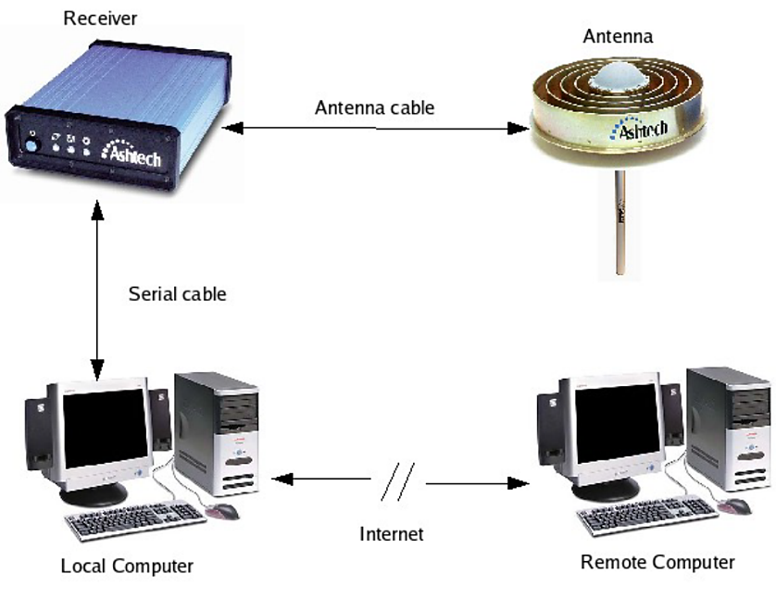

Figure 2: Overview of the GPS Data Acquisition System for SCINDA [6]

In this study, the analysis of the scintillation and TEC data has been carried out using the GPS TEC analysis application software called WinTEC-P, which was developed by Carrano and Groves (2009) at the Institute of Scientific Research, Boston College, USA. WinTEC-P utilizes the GPS-SCINDA ionospheric statistics file (*.scn) and the position file (*.psn) to obtain coordinates of the station, if it is not specified in its configuration. The software includes an algorithm for the estimation and removal of instrumental biases associated with the GPS receiver and the GPS satellites. The biases free TEC (Vertical TEC) and s4 index are written in ASCII output files together with other parameters defining the position of the satellite such as the time, elevation angle, azimuth angle, and the longitude and latitude of the Ionospheric Pierce Points (IPP). It also includes programs written in the GNU R to plot S4 and calibrated TEC and Perl Scripts to automatically generate and archive daily S4 and TEC plots with 15-minute updates.

The fluctuations in the signal intensity or severity of amplitude scintillation is measured by the scintillation intensity index S4 which is defined as the normalized variance of the signal power [7].

Where I is the signal intensity (amplitude squared) averaged for 60 seconds.

## Method of Analysis

For this study the scintillation occurrence of the data collected at equatorial anomaly station Bahir Dar are examined throughout the descending high solar activity period of January 2010 to December 2010 by dividing it into three seasons, E-months (March, April, September, October) D-months (November, December, January, February), J-months (May, June, July, August). The estimations were also limited to measurements made from satellites with elevation angle higher than 300. GPS scintillation occurrence is investigated separately in hour, month, and seasonal variation. In order to study the level of scintillation we have chosen four distinct thresholds which are named as weak, moderate, strong and saturated as given by Gwal et al., (2004) shown in table 1.

|  |  |
| --- | --- |
| **Thresholds** | **S4 index** |
| weak | 0.2< S4≤0.4 |
| moderate | 0.4< S4≤0.6 |
| strong | 0.6< S4≤1.0 |
| saturated | 1.0< S4≤1.4 |

Table 1: level of scintillation

# Result and Discussion

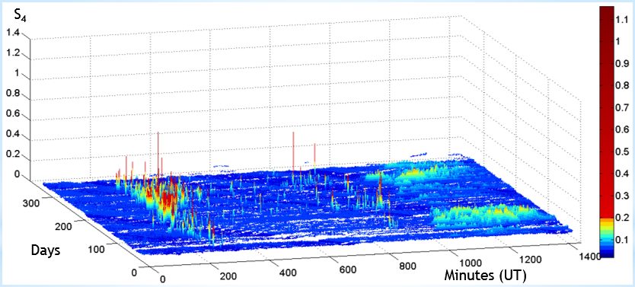Ionospheric scintillation index and total electron characteristics are plotted by using more than five million raw data from 32 satellites. Figure 3 presents the diurnal variation of S4 from January to December 2014. The general trend shown by the surface plots indicate that the S4 value range from 0.02 to 1.14. Particularly, the smallest values are observed from 0200 to 2000 in almost the cases. The relatively high values are observed from 2000 to 0200 and ranged from 0.08 to 0.14. This general trend confirms the fact that the scintillation is significant during the night. However, it can be seen from figure three that small amount of intense scintillation occurred during the day time. The result generally exhibits an occurrence frequency of scintillation observed mainly at nighttime hours (2000-0000 extended to 0200 LT in some cases).

Figure 3: Diurnal variation of S4 from January to December 2014

A typical representation of the variation of the TEC for the period under consideration is shown in figure 4. The legend in the figures shows the graduation of the geomagnetic Latitude (MLAT) of the satellite pass. The TEC follows a three-segment process as expected in a low-latitude station. At the beginning TEC attains a value of zero about 04:00 UT and quickly increases to reach a maximum value of 25 TECu at about noon forming a plateau, which is a comparatively stable region for about three hours before going to the decay region with a value of 3 TECu at 22:00 UT.

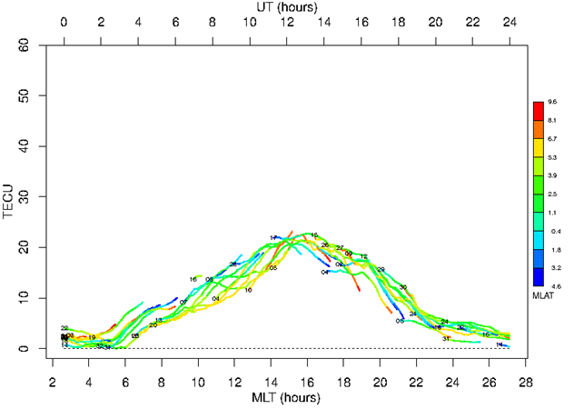

Figure 4. Typical diurnal variation of VTEC

The diurnal variation of VTEC from January to December 2014 is presented in figure 5a & b. The surface plot indicates that the minimum value is near sunrise, then TEC increase until maximum value is around 1400-1500 L T, after that decrease through the night. It also indicates that the VTEC value range from 5 to 45.

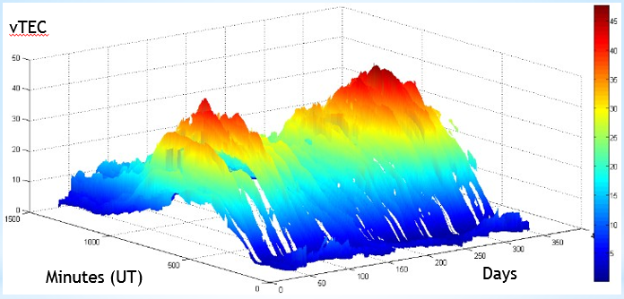

Figure 5a: Diurnal variation of VTEC shown in 3D plot from January to December 2014

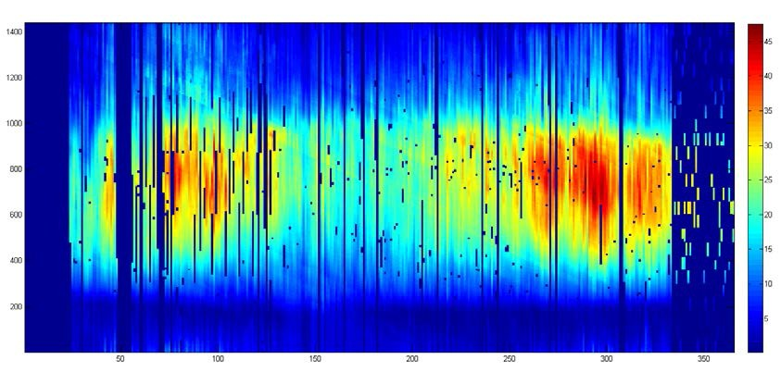

Days

Minutes (UT)

VTEC

Figure 5b: Variation of VTEC in the year 2014

The monthly variation of the scintillation index S4 is shown in figure 6. In all the plots, larger proportion of the data lies below 0.1, and sparsely distributed at higher values. At unity and beyond, the data were extremely rare, even during active periods of scintillations. March, April, February, September–December recorded scintillation events at moderate and intense levels, and these events were generally localized within 1930LT–2400LT, although, the distributions were observed to extend to around 0300LT during January, February and December. All other months experienced weak scintillation of various degrees of occurrences.

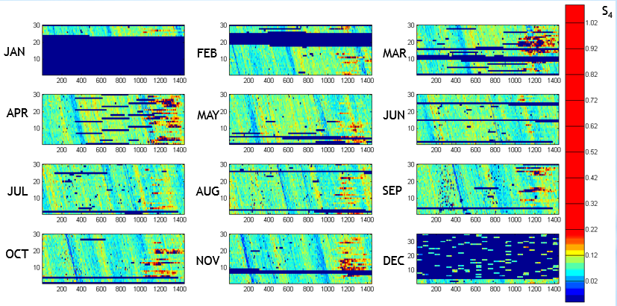

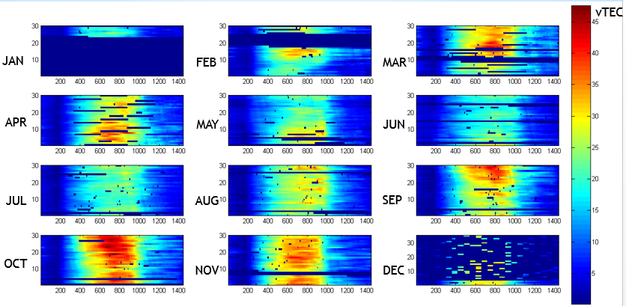Figure 6: Monthly variation of the scintillation index S4

Figure 7: Monthly variation of the vTEC

Separately for each month, the result for the vTEC is presented in figure 7. The diurnal variation shows that vTEC variation depends on the solar zenithal angle. vTEC values are lower than 20 TECU from midnight to 1100 and from 1700 to midnight. The highest values of vTEC are spotted during the day and particularly around 1500 LT where we have values greater than 20 TECU. The highest values are observed in the months of March, October and September.

# Conclusion and Future work

Based on the analyzed amplitude scintillation GPS-SCINDA data for year 2014, the following conclusions can be drawn.

* At our location we have frequent occurrence of weak ionospheric scintillations, while few intense scintillations.
* Intense scintillation occurred during the day time with a small frequency and relatively moderate scintillation occurrence during the night time with very frequent occurrence of scintillation.
* The maximum numbers of amplitude scintillation events are observed in equinox and minimum in summer.
* In summer, winter and equinox, high scintillations occurred at 19:00:00, 21:00:00 and 22:00:00 in pre-midnight local time hours respectively, while at in post mid-night period it is 04:00:00, 00:00:00 and 01:00:00 local time hours respectively.

# Reference

[1] G. Prölss, *Physics of the Earth’s Space Environment: An Introduction*. 2004.

[2] E. J. Liberman, “HOLES: IONOSPHERIC SCINTILLATION GPS AND IMPUTATION,” no. March, 2015.

[3] A. W. Wernik, J. A. Secan, and E. J. Fremouw, “Ionospheric irregularities and scintillation,” *Adv. Sp. Res.*, vol. 31, no. 4, pp. 971–981, 2003.

[4] T. C. Miller and R. J. Sullivan, “Ionospheric Scintillation Effects on a Space-Based , Foliage Penetration , Ground Moving Target Indication Radar,” no. August, 2001.

[5] C. S. Carrano and K. M. Groves, “The GPS segment of the AFRL-SCINDA global network and the challenges of real-time TEC estimation in the equatorial ionosphere,” *Proc. Inst. Navig. Natl. Tech. Meet.*, vol. 2, no. January, pp. 1036–1047, 2006.

[6] C. S. Carrano, “GPS ­ SCINDA : A Real ­ Time Gps Data Acquisition and Ionospheric Analysis System for Scinda,” no. X, pp. 1–62, 2007.

[7] X. Pi, A. J. Mannucci, and A. Freeman, “Global Distribution of L-Band Ionospheric Scintillation,” pp. 1–4, 2011.